## WRITEUP:

**GITHUB LINK:** <https://github.com/SweathaRJ/JAVA-FSD-PHASE5/tree/main/AmazonEC2App>

Step 1: Create a Spring Starter Project and add spring web in it.

Step 2: Create a Controller Class.

MainController.java

**package** com.example.demo;

**import** org.springframework.web.bind.annotation.GetMapping;

**import** org.springframework.web.bind.annotation.RestController;

@RestController

**public** **class** MainController {

@GetMapping("/")

**public** String hello() {

**return** "Hello! This is the Amazon AWS EC2 App...";

}

}

Step 3: Give component scan in application.java

AmazonEC2AppApplication.java

**package** com.example.demo;

**import** org.springframework.boot.SpringApplication;

**import** org.springframework.boot.autoconfigure.SpringBootApplication;

**import** org.springframework.context.annotation.ComponentScan;

@SpringBootApplication

@ComponentScan("com.example.demo")

**public** **class** AmazonEc2AppApplication {

**public** **static** **void** main(String[] args) {

SpringApplication.*run*(AmazonEc2AppApplication.**class**, args);

}

}

Step 4: Run it in

* Maven clean
* Maven build
* Maven install

Step 5: Refresh the project and now in target folder jar file will be created.

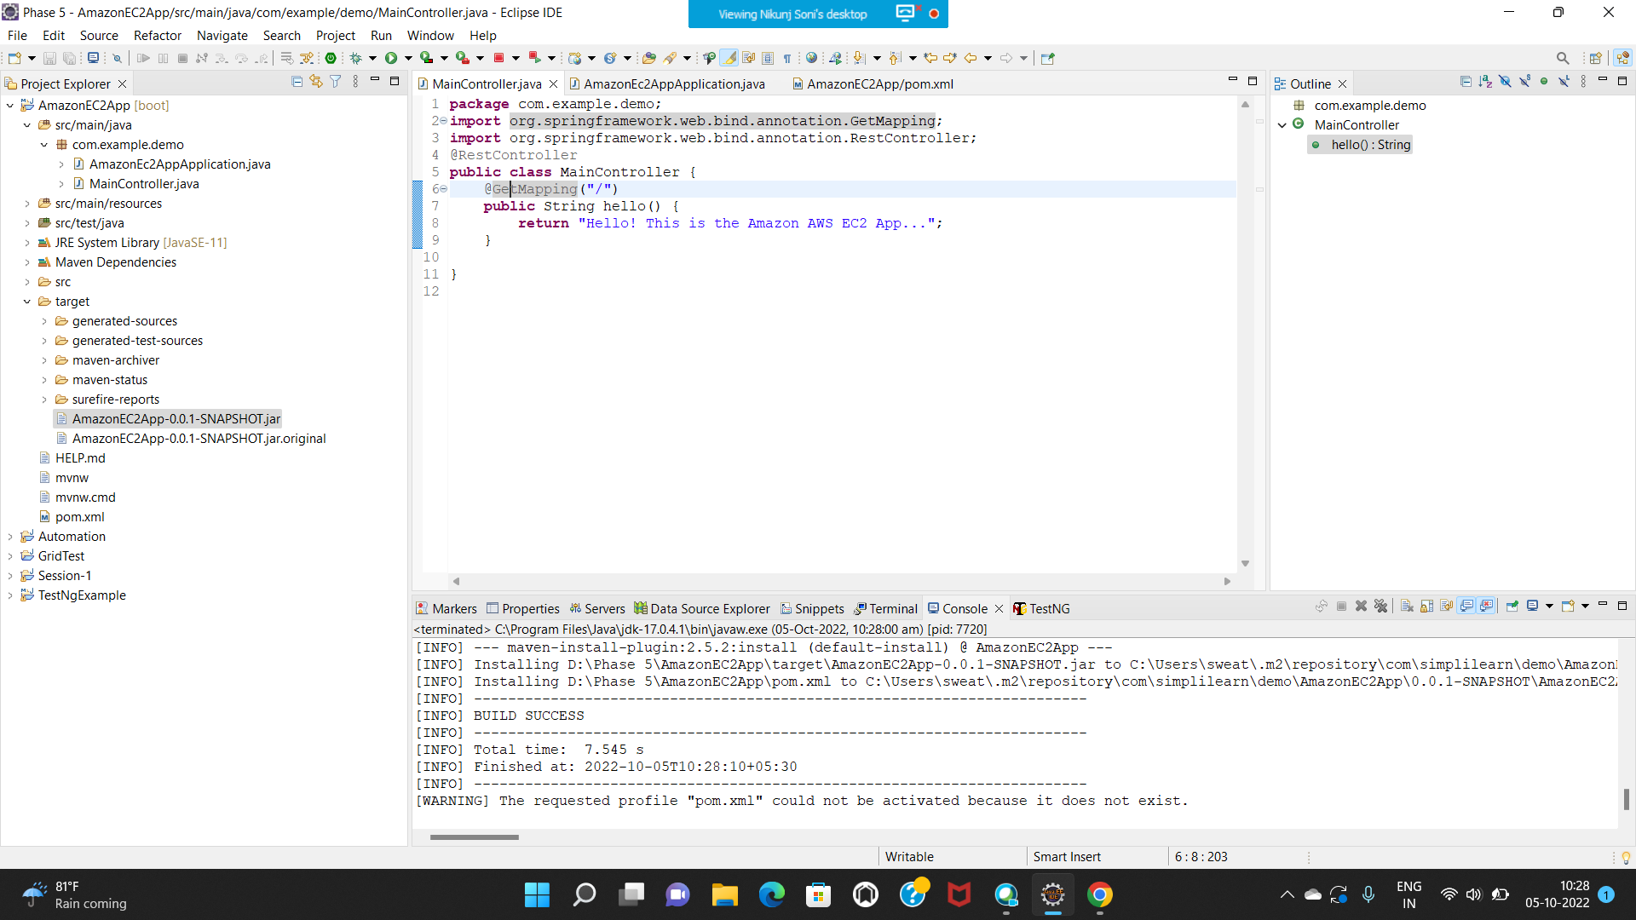

Step 6: Create one instance in AWS EC2. Choose Ubuntu Server 22.04 LTS (HVM). Add port number 8080 with Custom as MyIp.

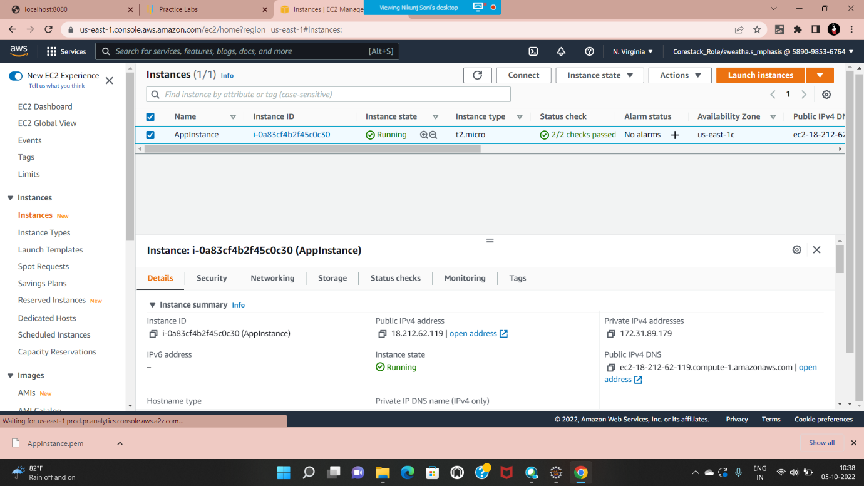

Step 7: Download the .pem file and copy and paste to the desired root directory.

Step 8: Connect to the Moba x-term

Step 7: Install JAVA-11 on Amazon EC2 Instance

Perform the following commands.

* sudo apt update
* sudo apt install default-jre

Step 8: Install maven

* sudo apt update
* sudo apt-get install maven

Step 9: Drag and copy the jar file to the Moba x-term

Step 10: Run the application.

* java -jar APP_NAME-0.0.1-SNAPSHOT.jar

EG: java -jar AmazonEC2App-0.0.1-SNAPSHOT.jar

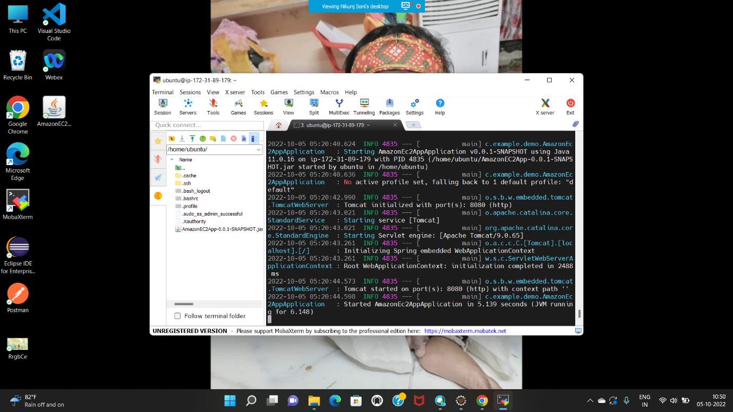

Step 11: Once tomcat get started copy your PublicIpAddress:8080 in browser and output will be shown.

